The New Organizational Template:
How to Design Work and Workplaces for Employee Health & Well-Being

This title implies that we have a new organizational template for organizations, but unfortunately, we do not. The mission of the Interdisciplinary Center for Healthy Workplaces (“Center”) is to create a Center that is based on the best known science across multidisciplinary fields regarding factors that significantly impact employee health and well-being. It may take years, or it may only be a matter of getting a diverse set of experts together to talk and integrate their knowledge into a coherent and practical organizational strategy. The Center is striving to fulfill its mission by gathering all the known facts and research findings across a wide range of academic and research fields, identifying gaps in our existing knowledge, supporting interdisciplinary research to narrow those gaps, and integrating all known science into a coherent picture of how a healthy workplace looks, feel, operates, and stimulates healthy work behaviors, habits and personal lifestyle choices. Once this template is developed, the Center will disseminate the template and serve as an enabler of researchers and practitioners dedicated to addressing the nation’s health crisis and facilitating effective organizational outcomes and employee behaviors.
Even without a template, there is a lot to say about healthy workplaces, fortunately. This paper presents a brief summary of major findings regarding employee health and well-being based on the scientific literature, and summarizes current and emerging approaches to preventing illness and injury in organizations, promoting health and well-being in the workplace, and mitigating health problems through organizational programs. I also offer suggestions for new research and new approaches to research on employee health and well-being in order to significantly improve our chances of turning the corner on growing health crisis. But first, let me describe the size of the problem we are facing.
The Global Health Crisis
Let’s calibrate. The Organisation for Economic Cooperation and Development (OECD), a consortium of countries representing Europe, South America, Asia, and the Middle East for the purpose of working together to share experiences and seek solutions to common problems. Among other things, the organization collects data on a variety of issues including population health/illness and predicts future trends. OECD found that more than 60% of the United States population is overweight or obese, and if the trend continues, 50% of the population will be obese by 2030 (about 15 years from now). Moreover, the US has the highest rate of obesity among its 34 member countries. Figures 1 and 2 show the status of the US stands in relation to other OECD countries. The prevalence of obesity ranges from a low of 4% for Japan and Korea, to nearly 35% for the US. This means that today, one in three Americans is obese.

Figure 1: Comparison of Obesity Rates Across Countries

Figure 2: Obesity Rates Across 34 OECD Countries
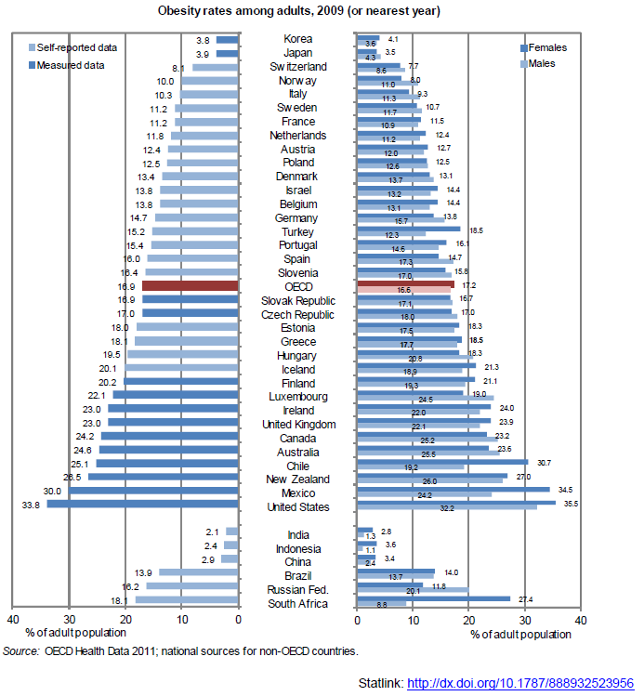

The incidence and prevalence of diabetes are equally concerning. It is believed that diabetes will become the number one burden of disease over the next decade. The International Diabetes Federation reports that in 2012 the worldwide cost of diabetes was estimated at $US 471 billion, and there were 4.8 million diabetes-related deaths worldwide. The western pacific region had the highest prevalence of diabetes in the world. Global diabetes rates are presented in Figure 3 below.

Figure 3: Global Diabetes Rates, 2012
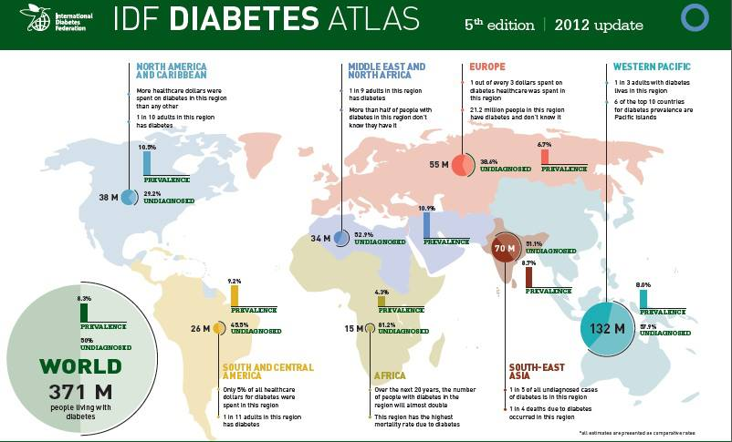

Globally, humans exhibit insufficient physical activity. Figure 4 shows the prevalence of insufficient physical activity globally. Up to half (40-49%) of all Americans ages 15+ exercise less than five times a week for 30 minutes of moderate activity or less than three times a week of 20 minutes of vigorous activity, or the equivalent. Several countries hold the same status as the US and even a few show even higher levels of physical activity insufficiency; however, this map shows that most of the world population experiences healthy levels of physical activity.

Figure 4:

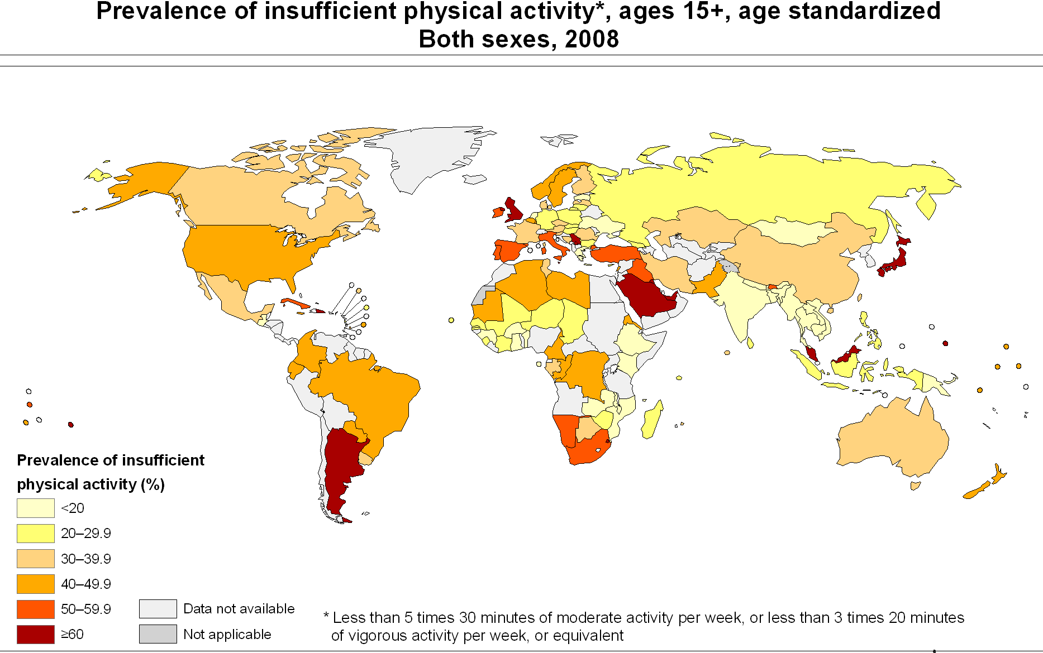

In addition, more than 450 million people across the world suffer from mental disorders including schizophrenia, depression, epilepsy, dementia, alcohol dependence, and other mental neurological and substance-use disorders. Mental disorders make up 13% of the global disease burden.

The World Congress on Safety and Health at Work reported in 2011 that of all the fatal occupational diseases, 29% consisted of work-related cancers, 21% were circulatory diseases and 25% were communicable diseases. The World Congress also reports that psychosocial factors, such as stress, harassment and violence at work have a significant impact on employee health and that stress is a factor in 50-60% of all lost working days. Recent research also shows that stress at work and high-level decision authority increases the risk of depressive and alcohol and drug-related disorders. Table 1 below shows that for both fatal and non-fatal work-related accidents and diseases, the absolute numbers of accidents and diseases have not declined appreciably despite many years of education and design changes in workplaces to make them safer.

Table 1: Global Trends in Fatal and Non-Fatal Work-Related Accidents
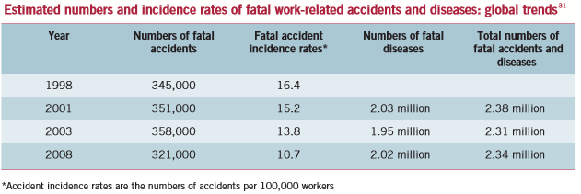

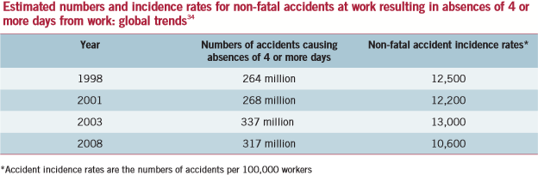

Presenteeism, defined as the condition where employees who are physically present at their jobs but experience decreased productivity because of illness or other barriers to performance, accounts for a significant portion of productivity losses in organizations (Prochaska et al., 2011). As shown in Figure 5 below, depression, diabetes, hypertension and allergies lead the list of medical conditions contributing to presenteeism in the workplace. Other factors relating to childcare, financial problems, addiction, divorce or other family difficulties also have been found to contribute to presenteeism. Still another significant factor is employees going to work while ill in order to preserve their sick leave entitlements.

Figure 5:

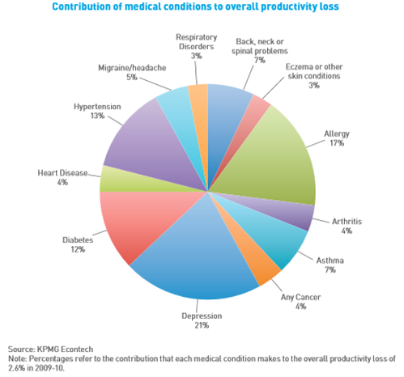

Finally, as seen in Figure 6 the World Health Organization projects that deaths due to cancer, diabetes, ischemic HD and stroke will increase significantly through 2030. Other causes of death such as traffic accidents, HIV/AIDS, and malaria will decline, undoubtedly because of better treatment options and better safety measures. It is likely the case that work-related factors are contributing significantly to the rise in deaths due to increasing stress levels, poor work habits, toxic work environments, and the lack of access to healthy food at work.

Figure 6: Global Trends in Selected Causes of Death

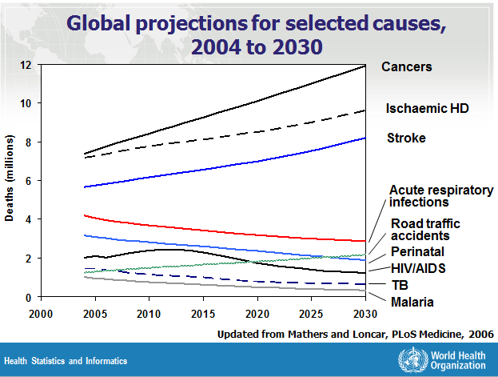

In summary, organizations are faced and will continue to be faced with very challenging health problems among their employees—those caused by poor lifestyle habits and those caused by work and work-related factors. Employees with certain adverse health factors such as obesity, sleep deprivation, poorly controlled diabetes, being a smoker, abusing drugs and/or alcohol, or being impaired by certain prescription medications, are more likely to sustain injuries than those without such risks. Employees who come to work suffering from depression, diabetes, hypertension, allergies and other medical conditions and who come to work ill are likely to underperform due to these conditions. Job burnout, described as a sense of overwhelming exhaustion, feelings of cynicism, detachment from the job, and a sense of ineffectiveness, also contributes to physical and emotional ailments and to lower productivity, absenteeism and turnover. There is no doubt that with the declining health of American workers at all organizational levels, our society will be greatly challenged to manage the cost of healthcare and to maintain productivity levels sufficiently to sustain the American economy.

Current Approaches to Addressing the Health Crisis

Several different approaches are designed to address employee health issues. One group consists of preventive interventions. These interventions are what we typically think of health and safety issues. Examples are occupational health and safety programs to help employees work more safely, avoid safety hazards, and address safety concerns before they cause illness and injury; health screening programs to identify and address early signs of illness or disease; educational campaigns such as smoking cessation and diabetes control; counseling programs such as weight-reduction, and medication adherence support programs to address current medical conditions such as high blood pressure, high cholesterol, and diabetes. The thrust of these interventions is to make things “less bad.”

A second set of approaches consist of programs that promote employee health. These include the use of ergonomically correct furniture, access to healthier food options at the worksite, on-site clinics for medical screening and well-checks, access to fitness equipment and programs, nurse advice lines to address emerging health issues, wellness fairs that promote healthy habits and lower healthcare costs, and organizational policies and practices that promote health such as “taking the stairs instead of the elevator” and food labeling in the cafeteria. The thrust of these interventions is to make things “more better.”

The third set of approaches consists of programs designed to mitigate health issues that employees already have. These include Employee Assistance Programs (EAP) designed to mitigate mental health, substance abuse, work-life balance issues, time-management and child/elder care issues; absenteeism management programs that help minimize time spent away from work following injuries and manage short-term disabilities; Return to Work programs designed to arrange for modified or restricted duty assignments to match medical limitations; and organizational justice and diversity programs that attempt to resolve equity and fairness issues that arise in the workplace. The thrust of these interventions is to resolve existing health and well-being problems that already exist.

A review of the literature on the efficacy of each set of programs revealed the following:
- The impact of these interventions is either unimpressive or unknown.
- Optional programs that employees have to elect to participate in show low participation rates overall.
- There are differences in access to and participation in optional programs by organization level: the higher the organizational level, the more likely the employee will participate, and the lowest participation rates occur among blue-collar and non-professional employees.
- Access to and participation in optional programs also varies by socio-economic status: employees in the lower SES strata are least likely to take advantage of these programs for several reasons including access to and extent of healthcare coverage, supervisors who control worker access to worksite health activities, working overtime, shift work, having a second job, car-pooling to work, long distances between the worksite and worker’s home, and responsibilities at home.
- Average participation rates for employees in the following health promotion programs are: health risk assessments (46%), clinical screening (46%), fitness programs (21%), smoking cessation programs (7%), weight loss/obesity (10%), and disease management (16%).
- For those who participate in programs that target specific personal health habits or activities such as tobacco use, body mass index and obesity, cholesterol, hypertension, stress, diet, alcohol abuse, seat belt use, fitness and physical activity, evidence suggests modest changes in employee behavior, modest reductions in medical costs, and significant decreases in the utilization of health care. Most programs show short-term changes, however.
- Some evidence suggests that the return-on-investment (ROI) for every dollar invested in health promotion programs ranges from $1.40 to $4.70 over a three-year period. Prevention programs have been shown to reduce medical costs by $3.27 and reduce absenteeism costs by $2.73 for every $1.00 spent on these programs.

Why have these programs generated such limited success? Although the answer to this question is not simple, I can offer several potential explanations based on my review of the literature:
- Most programs involve a single-factor approach. Focus on a single factor ignores other factors that also influence behavioral outcomes, and without controlling these other factors, any progress made with employee health and well-being may be mediated by the effects of other factors, thus limiting the impact of any single factor. For example, having ergonomically correct office furniture does not address other issues present in the workplace like cognitive overload from high work demands and poor options for child/elder care.
- Most approaches involve programs that are external to the work itself. As seen above, participation rates are low on average for preventive, health promotion and health mitigating programs, and this suggests that giving employees a choice to participate severely limits the potential impact of any program. By creating a program that is separate and apart from an employee’s daily work, the organization sets up a competition between involvement in that program and involvement in other activities (e.g., leisure, other jobs, other responsibilities), and the choice will tip in the direction of the activity that is perceived to have greater value to the employee. Because it is elective, the organization loses control of the health/well-being issue being addressed and consequently, gains less for the investment made.
- Interventions are rarely evidence-based. Because research evidence is lacking for many of the health and well-being programs now being implemented in organizations, there is little accumulated knowledge to direct the creation of programs or the selection of programs offered by vendors to organizations for implementation. The presumption is that any program offered will be successful, especially if it has a lot of “bells and whistles.” However, without the scientific evidence supporting program efficacy, organizations select and implement programs with unknown effectiveness.
- Behavior change is elective. Most programs attract participants to a healthier set of habits or to changed behavior based on education and coaching. The fundamental problem with such programs is that employees can elect not to change. There are no consequences for not changing, and therefore there is little incentive to change. Even if an employee is promised to feel better and to experience a better life by changing his or her behavior, these outcomes often appear distant in the future to have a motivating effect. Intrinsic motivation to succeed in the program is required for behavior change to be attempted and maintained over a significant period. That intrinsic motivation is often missing for employees who are most in need of behavior change.
- Leadership and management are not sold on health and well-being programs. Because most health and well-being programs are external to the work itself and thus, take an employee away from the job to participate in the program, supervisors and management may not release employees from their work to participate or may discourage employees from participating. Leadership also may be ambivalent towards these types of programs because the link between them and more positive organizational outcomes is perceived as weak and may go in the opposite direction from expected. That is, the expense made in these programs will never be made up by increased productivity or lower employee-related costs, and therefore will be a drain on the business. A lack of support by leadership and management could be a significant factor in employees’ low participation rates.
- Too little investment in health and well-being programs. Because these programs are considered to be “up-front costs” and therefore, lower the organization’s bottom line initially, organizations are incentivized to make the smallest investment as possible. Without knowing the return expected from these investments, organizations are most likely to make conservative investments. However, the investment may be insufficient to attract employees into the programs the organizations provide or to provide the necessary assistance to employees to cause real change, thus ensuring that the investment will not pay off as hoped. When facing uncertainty in benefit resulting from such programs, organizations are unlikely to make the kinds of investments needed to put in the kinds of programs needs to address employee health and well-being in a comprehensive or even limited way.
- The nation’s health crisis is a “wicked” problem. A wicked problem is one that is multi-faceted, involving interdependent parts and having no obvious solution. Because the promotion of health and well-being is a wicked problem, it demands a complicated, multi-pronged solution. Affecting one aspect of the problem does not resolve all other issues that impact other aspects of the problem. We cannot expect to turn unhealthy employees into healthy ones through a single preventive or health promotion program; likewise, we cannot produce well-being in employees through a single intervention. A wicked problem demands a wicked solution. From the literature, employee health and well-being has to be addressed in several ways on multiple levels and has to address the physical, psychological, emotional and social aspects of an employee’s life.
According to the research, what appears to be promising avenues to pursue in the creation of a healthy workplace template? The following is a list of factors that seem to be useful components of a healthy workplace:
- Worksite health promotion programs such as fitness and physical activity;
- Illness and injury prevention programs such as safety awareness and accident avoidance;
- Well-being design principles such as natural light, natural ventilation, non-toxic materials, and worksite design;
- Psychosocial and emotional intervention such as employee involvement and engagement, fair process and supportive social communities;
- Ergonomic-friendly work involving desk and seat design and technology use;
- Nutritional education and nutritional food access and labeling;
- Job design and workload management;
- Organizational justice/positivity/equity policies and procedures;
- Work/family balance such as accessible daycare, leaves of absence, and work flexibility; and
- Mindfulness practice such as meditation and relaxation.

Singly, all of these factors show some albeit limited success in promoting overall employee health and well-being. There is an opportunity to achieve much greater gains by looking at the integration of these separate approaches into a holistic health and well-being strategy. We know from experience that while you may be able to address one issue in an employee’s life that results in a positive effect, ten other things may act to undermine that gain. For example, a physical exercise program may help an employee reduce his/her body mass index but the workload is too great to take advantage of the program very often or he/she may get more exercise but also worries constantly about sick kids or sick parents at home. There is a growing awareness among researchers and practitioners who want to address health and well-being issues that what we are doing now is not working---we need to take an entirely different approach.

Possible Path Forward
This new approach requires a new set of design parameters in order to have the breadth and depth to address many of the issues that impact employee health and well-being at the same time, thus offering a comprehensive solution. These parameters are elaborated below:
- The approach is multi-pronged, comprehensive and integrated. Any solution has to stem from multiple perspectives and address multiple concerns at the same time, and the associated interventions need to be integrated into a comprehensive solution.
- Interventions need to be “baked in” rather than elective. Employee choice can’t be the only way to drive healthy habits. Alternatively, we can make healthy behavior part of how people work and part of the place they work in so that participation is not an issue. External programs of course could be added to the solution, but we need to make healthy work behavior part of the organizational culture and work itself and an everyday experience.
- Interventions are evidence-based. This requirement is a given; any comprehensive solution involves well-established science and that science is translated into practical approaches to health and well-being interventions. Interventions based on common sense or other basis that does not have a proven scientific foundation will be discouraged.
- Long-term and high-level commitment obtained organization-wide. To ensure success of this new approach, we need to secure long-term, high level commitment from leadership and management throughout the organization. An enduring commitment will provide to employees and their supervisors the necessary assurance that employee health and well-being are highly valued and worth the investment—for employees’ own sake.
In a workshop given to organizational practitioners, I asked workshop participants to delineate their vision of what a healthy workplace looked like given their understanding of the research findings in health and well-being research. After reviewing and discussing the overall research findings and best practice summary included in Appendix A of this report, the participants generated the following vision:
- An organizational culture that values self-respect and respect for others;
- An organizational culture that values inclusiveness and employee voice;
- High energy employees, engaged in their work and in the organization as a whole;
- Support for others in their well-being and care;
- Jobs designed that facilitate health: flexible and values autonomy;
- Workspace that allows personal privacy, has natural ventilation and natural light;
- A workplace that encourages physical movement and flexibility;
- Family-friendly work time and support;
- Nutritional food available and labeled to educate consumers;
- Opportunity to feed the spirit and personal happiness;
- Awareness of personal responsibility and accountability for health, safety and well-being;
- Leadership is a role model for healthy work behaviors, sharing the vision and living it;
- An internal organizational infrastructure to promote employee health and well-being—joining together the efforts of HR, IT, Real Estate, and Safety to create a solid and mutually reinforcing set of programs, policies and procedures.

This vision appears to be a very good start. The last component of the vision is particularly striking to me as it has the potential to solidify a “culture of health and well-being” within the organization. Such an infrastructure will reinforce healthy work behaviors throughout the organization and encourage decision-making that aligns with the organization’s values of health and well-being. Having a C-level officer managing this infrastructure would also ensure organizational alignment with these values and consistency in the development of organizational policies and practices that affect employee health and well-being. Components envisioned by these workshop participants make sense and may help guide future efforts to create the healthy workplace template.
Emerging Efforts Toward Total Health and Well-Being
Are there any new experiments or examples of progressive workplaces that do attempt to integrate many of these components into a health and well-being strategy? I highlight two companies, Microsoft and Google, which have taken on employee health and well-being head-on and have created new workplace designs and work practices that may produce significant results. They are described below.
Microsoft
Brian Collins, Global Manager of Workplace Strategy for Microsoft, was part of a global research project which attempted to identify the components of an optimal workplace for employee productivity and experience. Microsoft noticed changing work patterns across regions around the world, indicating a steady increase in mobility and less time in the office and at desks year over year. Consequently, Microsoft focused on the functionality of the workplace rather than on the traditional criterion of “asset optimization” which, from a real estate perspective, meant “cost.” By taking a function-based perspective, Microsoft was able to determine employee needs by location and by role.
The research identified five distinct work patterns called “work styles,” each work style reflecting a different amount of time spent in the office and working at a desk with or without the need for private conversations. Assuming that “not one size fits all,” Microsoft teamed up HR, corporate real estate, and IT to design new office space to match the needs of the different work styles. The result was a global corporate strategy called, “Workplace Advantage” (WPA).

Figure 7: Microsoft’s Five Work Styles

Workplace Advantage was rolled out with regional site councils in locations around the world, enabling local leadership to determine the types of workplace design that would optimize employee productivity and satisfaction given the work styles present in each location. Communications technologies were also strategically designed to measure productivity improvements that come from the use of its communication and collaboration software.
Microsoft also recognized that other improvements were needed, and they now offer the following to its employees at their corporate headquarters:
- Health and Wellness Center, a full-service clinic on campus with 20 physicians and multiple programs to meet employee primary and secondary care needs;
- Best healthcare plans as part of employee remuneration;
- A variety of food options in company cafeteria clearly marked to help employees make healthy choices;
- Running trails and “apps” to track how an employee is doing to stay healthy; and
- An organizational change management initiative to shift a culture of entitlement (private office, solitary work activity) to a culture of collaboration (informal conversation, interaction with others involved in the software development process).
The changes implemented at Microsoft go beyond space design. They involve workplace design plus changes in psychological processes that directly affect employee productivity and work satisfaction. They involved experts from multiple fields (HR, IT, Corporate Real Estate, Organizational Development, Environmental Design) to generate workplace solutions. Brian Collins also has a place in the C-suite. More important, the team of experts review analytics tied to workplace changes to understand the impact of these changes. They purposely share knowledge across the team that is different from their everyday expertise (called “unconventional knowledge”), and synthesize this knowledge into new workplace designs. This approach of multi-disciplinary teams sharing and synthesizing information and co-design of workplace changes appears to be a critical component of the company’s workplace strategy. Figures 8-10 show examples of the changes that were made at its offices. It is clearly yielding important organizational outcomes.

Figure 8: Vienna Location Demonstrating Fun, Natural Materials and Integration of Nature

Figure 9: London Location Demonstrating Design for Collaboration

Figure 10: Redmond Location Demonstrating Colors, Light, Texture, and Flexibility
Google
Google is well-known for its innovations in workplace design and workforce strategy, and leadership at Google has also addressed employee health and well-being issues head-on. According to the leadership, they want to “create and manage a workplace that will help the company thrive while making the world a better place.” Lazlo Bock, head of Human Resources at Google, stated that Google wants employees to stay for life, and to do so, Google has to be concerned for employees’ health and well-being. Toward that end, Google has put in motion a multi-pronged strategy. Figures 11-15 show examples of how this strategy was operationalized.
- Sustainable eating by introducing organic food and beverages into the cafeteria and coolers around campus
  - 45% of produce is organic;
  - Buy from community supported fisheries to bring in fresh seafood every week;
  - Put the healthiest products at eye level and make less healthy food hard to find/reach;
  - Color code foods to signal the degree of “healthiness”
  - Use small plates in the cafeteria;
  - Try to include vegetables in every food offering;
  - Make healthier options available at all times such as water;
  - Offer smallest size of snack foods;
  - Price food based on nutritional value
- Education and training of employees
  - On healthy eating to support personal decision-making based on Harvard School of Public Health Eating Pyramid;
  - Cooking classes and community gardens on campus;
- Elimination of chemicals in buildings and only using paints, sealants, adhesives, carpets and furniture with the lowest levels of VOCs and formaldehyde possible, and exclusion of toxic elements like lead and mercury;
- Use of sustainable materials that are locally manufactured, high in recycled content and biodegradable;
- Workplace designs and meeting places that are comfortable, private, fun, and convenient;
- Multiple opportunities for physical activity on campus including bicycles and other physical exercise vehicles to travel across campus, athletic fields and courts, gyms, and walking/running paths;
- Ergonomic furniture such as treadmill desks; and
- Rest and relaxation rooms to enable personal restoration.
Figure 11: Google Cafe
Figure 12: Google Private Meeting Spaces

Figure 13: Google Spontaneous Meeting Spaces

Figure 14: Google Personal Restoration Room

Figure 15: Google Pod for the Sleep-Deprived
These two companies have the resources and the right talent to make the kinds of changes in their organizations in order to make significant strides in improving employee health and well-being and in preventing illness and injury in the workplace. It is not surprising that both are tech companies dominated by relatively young, white collar professionals who are well-compensated—not the profile of employee most at risk of illness, disease and death by company-related accidents. Nonetheless, Microsoft and Google offer evidence that such changes can be made organization-wide and they produce positive personal and organizational outcomes.

Healthways
Healthways, Inc. is a global provider of well-being improvement solutions that works to significantly improve personal, organizational and community well-being by helping people stay healthy, reducing health-related risks, and optimizing care for those with chronic conditions. This organization is unique in that it has developed extensive measures of well-being based on science and then associates scores with targeted interventions ranging from specialized programs such as tobacco cessation, physical activity and medication adherence to individualized training, coaching, and education classes. Healthways then delivers programs to customers either by themselves or through other organizations to address existing health issues or to reduce health risks. They apply best practices and scientific knowledge to provide effective programs and motivational techniques to achieve greater participation, higher engagement and commitment to personal improvement. Healthways also address issues that reside in the broader context in which employees live and work in order to support healthy behavior.
Healthways partners with several organizations to extend its reach and impact. Healthways established a joint venture with the Gallup organization to create the Gallup-Healthways Well-Being Index® (WBI), a national measure of well-being based on psychology and medical science covering six content areas:
- Life Evaluation: Self-evaluation of present life situation and anticipated life situation five years from now;
- Emotional Health: Daily experience of enjoyment, happiness, worry, anger, stress, learning or doing something interesting, being treated with respect, depression, and others;
- Physical Health: Sickness, sick days in the past month, disease burden, health problems that get in the way of normal activity, obesity, feeling rested;
- Healthy Behavior: Lifestyle habits regarding smoking, healthy eating, consumption of fruits and vegetables, and exercise;
- Work Environment: Perceptions of the work environment such as job satisfaction, ability to use one’s strengths at work, treatment by supervisors, degree supervisor creates a trusting and open environment; and
- Basic Access: Access to basic needs of food, shelter, healthcare and a safe and satisfying place to live.
The purpose of the measure was to establish official statistics on the state of well-being in the United States. The Index is also used to track improvements in well-being as the result of interventions provided by Healthways to its customers and its partners. The Gallup organization conducts (by cell phone and landline) telephone surveys to approximately 500 adults (18 years or older) globally, 24 hours per day, 350 days per year. Healthways has more than 2 million surveys completed to date.
Healthways also created the Well-Being Assessment (WBA), a combined measurement of Well-Being comprised of four primary components:
- The Well-Being Index (described above);
- The Well-Being Assessment for Productivity (WBA-P), which measures an organization’s culture of health and uses measures of presenteeism and absenteeism;
- Biometrics such as blood pressure, cholesterol, and other basic physiological indicators of health; and
- Health Risk Assessment (HRA), which measures behavioral, physical and emotional health risks, based on the work of Dee Edington PhD, Director of the University of Michigan’s Health Management Research Center.
Individuals, organizations, communities and countries can be compared on each component of the WBA as well as the total WBA score. The measurement was developed to help drive individual improvement within customer populations using a personalized approach according to Healthways website. Having a comprehensive measure allows Healthways to examine a broad spectrum of potential health and well-being challenges and then propose integrated solutions to address these challenges in a systemic fashion.
Blue Zones Project
Blue Zones Project™ is a community well-being improvement initiative designed to make healthy choices easier through permanent changes in environment, policy, and social networks. By helping people live longer, better through behavior change, communities can lower healthcare costs, improve productivity, and boost national recognition as a great place to live, work, and play.
It’s based on findings from an eight-year worldwide quest led by Dan Buettner, National Geographic Fellow and New York Times Best-Selling Author, to find places where individuals live measurably longer, happier lives. These areas are called Blue Zones®. In 2009, Healthways partnered with Blue Zones to ignite a community-by-community well-being transformation. Together, they’ve developed a comprehensive set of solutions designed to systematically improve well-being by impacting the environment through policy, building design, social networks, and built environments.
People in Blue Zones areas share nine healthy lifestyle habits that have helped them live with greater well-being and longevity for generations. These principles are called the Power 9® and include the following:
- Move Naturally: Find ways to add movement to your day; walk instead of drive, climb stairs instead of taking the elevator, do your own house and yard work;
- Know Your Purpose: Create an internal inventory of your life; articulate your values, passions, gifts and talents; put skills into action that will add to the meaning of your life;
- Down Shift: Find a stress-relieving activity and make it routine;
- 80% Rule: Take things out of everyday diet instead of putting more in; eat on smaller plates; stop eating when 80% full.
- Plant Slant: Eat a fresh array of fruits and vegetables packed with disease-fighting nutrients; make beans the cornerstone of your diet;
- Wine @ Five: Drink one to two glasses of wine per day; drink the wine while you eat a meal with friends;
- Right Tribe: Create social circles that support healthy behavior; assess who you hang out with and then surround yourself with the right people;
- Belong: Attend a faith-based community which fits you and attend regularly; and
- Loved Ones First: Put your family first; invest time and love your children and other family members; have family members near to home.
Blue Zones Project selected the Beach Cities of the Los Angeles region as the first community in the US to participate in well-being improvement and transformation. The Blue Zones Project team worked with companies, schools, restaurants, residents and public institutions in the Beach Cities to change their behavior towards greater health and well-being. After two years of the Beach Cities project, the WBI and WBA revealed impressive gains in well-being improvement:
- Obesity dropped 14% with an estimated 1,645 fewer obese adults;
- Smoking rates declined more than 30% or 3,484 former smokers;
- Exercise rates increased by more than 10% as more people reported exercising at least 30 minutes, three times per week; and
- Healthy eating habits improved 9% with more people reporting eating five plus servings of fruits and vegetables four or more days in the past week.
These successes came about through the delivery of programs and education efforts in a systemic manner. This project shows that with integrated and systemic effort within a community, substantial improvements can be achieved. Additional Blue Zones Project initiatives are underway through Fort Worth, regions of Hawaii and throughout the state of Iowa.

Fitbit @ Work
A new biometric device, the Fitbit, has the potential to capitalize on many psychological principles for the purpose of helping individuals live better. The device measures a number of biological functions both during sleep and while a person is awake, and it reflects the eating, sleeping, and physical activity of its wearer. Measurement is the key to behavior change, and sharing measurement results with a social network rewards and reinforces health improvement. Wearers obtain instant feedback on physical activities such as number of stairs climbed, steps taken, calories consumed, calories burned, and other results of behavior. If the wearer moves close to his/her computer, the information is automatically downloaded to a file which maintains records of statistics and maps improvements/deficits and other results as requested. Information can also be uploaded through social networks to compare statistics with comparable others. The potential benefits of this device are supported by several psychological principles such as behavior feedback, goal-setting, peer pressure, accountability, and positive reinforcement. These psychological principles can be powerful motivators to make alternative choices which improve one’s health status. Although the Fitbit is not the answer to the health crisis, it could be part of the answer.

Gensler
Gensler, a global architecture, design, planning and consulting firm, has been behind several workplace make-overs to create both healthy and more productive workplaces. Gensler has recognized that “When people are engaged by their work, there’s a confidence and camaraderie that let them feel they can do anything…Companies that acknowledge this and design for it can accelerate that engagement” (Tom Vecchione). Gensler advises companies through their team of experts within the Well-Being Design practice. Gervais Tompkin, Principal of the San Francisco office, one of the global leaders of this practice, is currently working closely with several Fortune 500 companies including Microsoft, Salesforce, FaceBook, Google, Ericsson, Dolby and Citrix to help them create healthy workplaces. He is one of the key thought leaders in this practice. According to Tompkin, the number of companies jumping into this new way of thinking about the workplace is too numerous to list.
In 2008, the Gensler research team conducted a national study of 900 randomly-selected full-time in-office workers throughout the US to look at the relationship between physical environmental factors and human physiological and psychological health. Together with an independent research firm, Gensler created the Workplace Performance Index (WPI) which measures workplace effectiveness in terms of work mode criticality + workspace effectiveness for work modes + time spent + the quality of individual attributes of each type of work space (layout, light, air, storage, furniture, privacy/access). Study results showed that top-performing companies exhibited substantially higher WPIs than their less successful counterparts, giving design firms in general ammunition they need to lead change to healthier and more productive workplaces.
Based on Gensler’s research, 10 physical environmental factors were identified that have direct and indirect connection and influence on employee health and well-being. The 10 factors are:
- Activity (Work): The primary risk of ill health is sitting time. Integrating low intensity movement and exercise into the work day has positive benefits for the body and the mind. Key considerations are:
  - Standing/adjustable height work stations
  - Walking paths
  - Open stairwells
  - On-site physical activity (fitness centers)
- Water + Nutrition: Convenient access to fresh water and healthy food. Key considerations are:
  - Convenient sources of fresh water
  - Access, availability and labeling of food in vending machines and café
- LEED IAQ: Indoor air quality is a major factor in employee productivity. Key considerations are:
  - Air and water filtration
  - Elimination of VOCs (toxic materials)
  - Access to fresh air
- Physical Interaction with Nature: Direct contact with nature enables better focus, mental stamina, and productivity. Key interventions are:
  - Plants in the workplace
  - Access to the outdoors
  - Quality views of nature
- Restorative Environment: An environment that facilitates reading, meditation, relaxation, listening to music or other activities that restore calmness and focus. Key interventions are:
  - Music
  - Views of nature, natural sounds
  - Absence of distractions and noise
  - Areas of sound isolation and visual privacy
- Acoustics: Control low level noise and acoustical privacy. Key interventions are:
  - Elements of visual privacy
  - Improved acoustic performance of interior space
  - Improved HVAC acoustic performance
  - Planned collaborative and focus areas in the office
- Lighting: Control of artificial and natural lighting+ personal control and adoption to circadian rhythms. Key interventions are:
  - Minimized disruptions to circadian rhythms by varying color temperature + intensity
  - Daylighting + controls
  - Variable light levels
  - Bright colors in the work environment
  - Full spectrum lighting to supplement natural day lighting
- Ergonomics: Safe and comfortable individual work environment. Key interventions are:
  - Interruptions in long periods of sitting
  - Adjustable seating/workstations
  - Variable workstation postures during the workday
  - Adjustable height desks and adjustable keyboards and monitors
- Autonomy (User Control): Choice, control and adjustability of work settings and tools. Key interventions are:
  - Choice of worksettings
  - Personal control of storage, lighting and HVAC
  - Personalization of individual and team workspace
- Feedback Loops/Nudges/Motivators: Prompts, access, education, peer support and availability and promotion elements to change behavior. Key interventions are:
  - Easy choices
  - Fun choices
  - Benefits communicated
The Gensler research team mapped the 10 Factors on to a set of health and measures of health and well-being to show which interventions affect which health/well-being condition. The result is the following table:

Table 2: Relationship Between Health & Well-Being Meaures and the 10 Factors
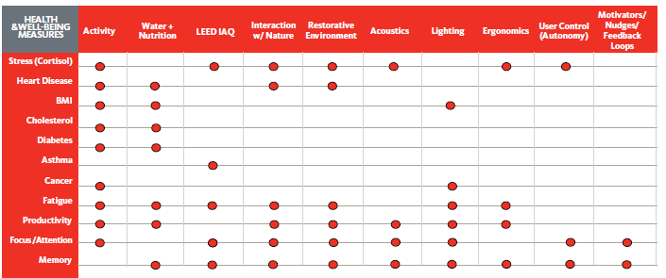

This matrix will be used as a guide for architects and designers to create workplaces that have the desired health and well-being impact.

Taking the Lead
The University of California, Berkeley has taken the lead in bringing together all known science associated with employee health and well-being across disciplines in order to understand how we might build a new organizational template that will promote employee health and well-being. The newly established Interdisciplinary Center for Healthy Workplaces (CHW), located on the Berkeley campus, collects research from all disciplines in this domain and assembles this research into a single repository for easy access. The Center’s mission is to integrate this multi-disciplinary research into a coherent picture of what a healthy workplace would look like—based on everything we currently know. This picture will be translated into a new organizational template—a set of guiding principles and recommendations based on empirical evidence—that organizations can follow and put into practice. The Center’s mission is also to promote new interdisciplinary research to advance our knowledge of how employee health and well-being can be improved, and to promote innovation in workplace design and organizational practices to meet employers’ and employees’ needs.
Currently, the Center is assembling teams of researchers representing different disciplines that will begin examining the known research literature and then integrating the literature into a coherent and integrated picture of research findings. Their job is to identify what we know and what we don’t know in this domain and given what we do know, what story does it tell about the factors that contribute to employee health and well-being. The critical part of their work is that they will be impartial and comprehensive in their reviews of the literature—both basic and applied. They will evaluate findings against the standards of good science, enabling reliable and valid knowledge to come forward and gleaning from the plethora of literature helpful and actionable knowledge. Companies desiring to implement costly changes into their workplaces need to know what is critical and what is not, and they need to know how it all fits together.
As part of their work, the research teams will map out future research needed to fill in the gaps and advance our knowledge in this domain. This will be an on-going activity of the Center. As the research evolves over time, our understanding of what we need to know will also evolve, continuously refining our understanding of organizational designs and practices that most effectively mitigate unhealthy conditions and health risks, and proactively promote employee health and well-being.
The Center is also engaged in pilot studies in which organizations engaged in redesign and organizational change efforts allow a Center research team to work alongside the designers and consultants to bring an interdisciplinary research perspective to the project planning, design and testing. These pilot tests are intended to demonstrate that a multi-pronged, multi-disciplinary approach to organizational change is possible and more important, beneficial. An interdisciplinary team consisting of social scientists, architects, engineers, public health, medical professionals, and business experts will be assigned to volunteer organizations, and their work will be tracked as a “case study” for the duration of the project. Results of the pilot study will be posted on the Center website for public viewing as a demonstration of the potential for this new approach.
The Center will gather not only published research into a repository; it will also attempt to gather information on all relevant parties engaged in the effort to increase employee health and well-being. These parties will include companies and organizations implementing health and wellness practices, institutions and research centers conducting research on relevant aspects within this domain, vendors that provide products and services within this domain, consulting firms and practitioners engaged in change management consulting associated with employee health and well-being improvement, and unaffiliated university researchers who publish in this domain. The Center’s intention is to be a “one-stop-shop” for the public to obtain the information in a single place regarding all known programs and experiments occurring within the US (and to some extent globally) engaged in this initiative. By doing so, we can inform the public of what is being done and what results have been accumulated, if any. There is no existing site which provides this valuable and needed information.
When the template is developed, the Center will focus on dissemination of the template to any appropriate audience to promote its adoption—employees, employers, consultants, executives, policy-makers, and practitioners. The Center will hold informational workshops, seminars, webinars, conferences, and training sessions to assist researchers and practitioners in their ability to serve their clients and the public. The Center will also publish publicly available papers and other forms of media to make the template and critical information most accessible.
The Center’s success will be evaluated two ways: (1) Did it create a template based on science that is both compelling and practical, and (2) Did it help all relevant constituencies take advantage of this knowledge and facilitate the desired changes?

Conclusion
The need for organizational change has never been so great. We are making ourselves sick the way we work, interact at work, eat at work, and live in the environment at work. This has to change, now.
Awareness of this need for change is growing, but we are just beginning to understand what needs to change and how it needs to change. We know there is no simple solution. There are growing efforts by environmental design firms and consulting firms to build change practices that will impact employee health and well-being. This is a good start, but unfortunately, there is more that needs to be done. Efforts that emphasize changes in the physical space still need to consider the psychological aspects more; those that emphasize the psychological and emotional space still need to consider the environment in which people work. We need to consider the entire picture because all of it is making us sick, so we need to address all of it with an integrated solution. And this solution must be based on scientific studies. There is plenty out there that argues this approach or that approach is best. Buyer beware—what is that argument based on? Since an integrated solution will be costly, let’s give it our best shot—let’s go with the best bets.
We have a chance to make significant progress addressing the health crisis in the US and improving our ability to meet our nation’s economic demands. What we need to do is work constructively together following a systematic process to uncover what we already know we must do in order to significantly impact our health and well-being and put it into practice. Please consider joining our effort to make this a reality.

References
AIHW & AACR. (2012). Cancer in Australia: an overview 2012. Retrieved from http://www.aihw.gov.au/WorkArea/DownloadAsset.aspx?id=60129542353
American Society of Safety Engineers. (2012). American National Standard for Occupational Health & Safety Management Systems.
American Society of Safety Engineers. (2011). ANSI/ASSE Z3590.3-2011, Prevention through design: Guidelines for addressing occupational hazards and risks in design and redesign processes.
Carney, D.R., Cuddy, A.J. C., & Yap, A.J. (2010). Power posing brief nonverbal displays affect neuroendocrine levels and risk tolerance. Psychological Science, 21, 1363-1368.
Comcare Australian Government. (2011). Effective health and wellbeing programs. Retrieved from www.comcare.gov.au
Consensus Statement of the Health Enhancement Research Organization, American College of Occupational and Environmental Medicine, American Cancer Society and American Cancer Society Cancer Action Network, American Diabetes Association, & American Heart Association. (2012). Guidance for a reasonably designed, employer-sponsored wellness program using outcomes-based incentives. Journal of Occupational and Environmental Medicine, 54(7), 889-896.
(C. Maslach, personal communication, June 15, 2013).
Danna, K. & Griffin, R.W. (1999). Health and well-being in the workplace: A review and synthesis of the literature. Journal of Management 25(3), 357-384. Doi:10.1177/014920639902500305
DeCaro, E. M., Hendricks, K., Altice, J., & Kelly, R. (2013, March). Evaluation of a university worksite-based total health program. Poster presented at the Work, Stress and Health 2013: Protecting and Promoting Total Worker Health™. 10th International Conference on Occupational Stress and Health, Los Angeles, CA.
Diabetes Australia. (2013). National Diabetes Strategy and Action Plan. Canberra: Diabetes Australia National Office.
(D. Scrimger, personal communication, June 10, 2013).
Duncan, M. D., Kazi, A., & Haslam, C. O. (2013, March). Working late: Organisational health intervention evaluations—What do participants find beneficial. Poster presented at the Work, Stress and Health 2013: Protecting and Promoting Total Worker Health™. 10th International Conference on Occupational Stress and Health, Los Angeles, CA.
Fox, S., Spector, P. E., & Miles, D. (2001). Counterproductive work behavior (CWB) in response to job stressors and organizational justice: some mediator and moderator tests for autonomy and emotions. Journal of Vocational Behavior, 59, 291–309.
Frontczak, M., Schiavon, S., Goins, J., Arens, E.A., Zhang, H., & Wargocki, P. (2012). Quantitative relationships between occupant satisfaction and satisfaction aspects of indoor environmental quality and building design. Indoor Air, 22, 119-131.
Gensler. (2013). Open source student spaces: Event discussion highlights of dialogues with Gensler event on Thursday, March 21, 2013. Chicago: Author.
Gensler. (2013). A framework for well-being based workplace design [PDF document]. Retrieved from http://www.gchc.org/wp-content/uploads/2013/05/4-Buggy.pdf
(G. Brager & S. Schiavon, personal communication, June 3, 2013).
(G. Cranz, personal communication, June 11, 2013).
Grant-Vallone, E. J. & Donaldson, S. I. (2001). Consequences of work-family conflict on employee well-being over time. Work & Stress: An International Journal of Work, Health & Organisations, 15(3), 214-226.
Grzywacz, J. G. & Carlson, D. S. (2007). Conceptualizing work –family balance: implications for practice and research. Advances in Developing Human Resources, 9, 455-471.
Harter, J. K., Schmidt, F.L., & Keyes, C.L. (2002). Well-being in the workplace and its relationship to business outcomes: A review of the Gallup studies. In C.L. Keyes & J. Haidt (Eds.), Flourishing: The Positive Person and the Good Life, 205-224. Washington D.C.: American Psychological Association.
Hymel, P.A., Loeppke, R.R., Baase, C.M., Burton, W.N., Hartenbaum, N.P., Hudson, T.W., Larson, P.W. (2011). Workplace health protection and promotion: A new pathway for a healthier—and safer—workforce. Journal of Occupational and Environmental Medicine, 53(6), 695-702.
International Labour Organization (ILO). (2011).ILO Introductory Report: Global Trends and Challenges in Occupational Safety and Health, XIX World Congress on Safety and Health at Work, Istanbul 11-15 Sep 2011. Retrieved from http://www.ilo.org/wcmsp5/groups/public/@ed_protect/@protrav/@safework/documents/publication/wcms_162662.pdf
Lee, D. J., Tannenbaum, S. L., Ocasio, M. A., Fernandez, C. A., & Fleming, L. E. (2013, March). Prevalence of mindfulness activities for stress reduction in the U.S. workforce. Poster presented at the Work, Stress and Health 2013: Protecting and Promoting Total Worker Health™. 10th International Conference on Occupational Stress and Health, Los Angeles, CA.
Maslach, C., Schaufeli, W.B., & Leiter, M.P. (2001). Job burnout. Annual Review of Psychology, 52, 397-422.
Medibank. (2011, July). Sick at Work. The cost of presenteeism to your business and the economy. Retrieved from http://www.medibank.com.au/Client/Documents/Pdfs/sick_at_work.pdf
Melikov, A.K. (2004). Personalized ventilation. Indoor Air, 14, 157-167.
Mhurchu, C.N., Aston, L.M., & Jebb, S.A. (2010). Effects of worksite health promotion interventions on employee diets: a systematic review. BMC Public Health, 10, 1-7.
Mitchell, J. A., Eden, B., Dunn, S., Cramp, J., Chapman, K., Jayewardene, V., King, L., & St. George, A. (2011). Healthy workplace guide: Ten steps to implementing a workplace health program. Retrieved from http://hdl.handle.net/2123/8776
National Institute for Occupational Safety and Health (NIOSH). (2012). Research Compendium: The NIOSH Total Worker Health Program: Seminal Research Papers. Washington, DC: U.S. Department of Health and Human Services, Public Health Service, Centers for Disease Control and Prevention, National Institute for Occupational Safety and Health, DHHS (NIOSH) Publication No. 2012-146, 1-214.
Occupational Safety & Health Administration (OSHA). (n.d.). OSHA commonly used statistics. Retrieved from https://www.osha.gov/oshstats/commonstats.html
OECD. (2012). Obesity Update 2012. Retrieved from www.oecd.org/dataoecd/1/61/49716427.pdf
Oliver, K. K. (2013, March). The effect of autonomous motivation and situational constraints on organizational commitment and turnover intentions. Poster presented at the Work, Stress and Health 2013: Protecting and Promoting Total Worker Health™. 10th International Conference on Occupational Stress and Health, Los Angeles, CA.
Schiavon, S., Melikov, A.K. (2009). Energy-saving strategies with personalized ventilation in cold climates. Energy Builds, 41, 543-550.
Seppänen, O. A. & Fisk, W.J. (2002). Association of ventilation system type with SBS symptoms in office workers. Indoor Air, 12, 98-112.
Singh, A., Syal, M., Korkmaz, S., & Grady, S. (2011). Costs and benefits of IEQ improvements in LEED office buildings. Journal of Infrastructure Systems, 17, 86-94.
Story, M., Kaphingst, Karen M., Robinson-O’Brien, R., & Glanz, K. (2008). Creating healthy food and eating environments: policy and environmental approaches. Annu. Rev. Public Health, 29, 253-72.
Sundell, J., Levin, H., Nazaroff, W., Cain, W., Fisk, W.J., Grimsrud, D. . . Weschler, C.J. (2011). Ventilation rates and health: multidisciplinary review of the scientific literature. Indoor Air, 21(3), 191-204.
Tepper, B. J. (2001). Health consequences of organizational injustice: Tests of main and interactive effects. Organizational Behavior and Human Decision Processes, 80(2), 197-215.
U.S. Environmental Protection Agency. (2009). Buildings and their impact on the environment: A statistical summary [PDF document]. Retrieved from http://www.epa.gov/greenbuilding/pubs/gbstats.pdf
Veitch, J. A. (2011). Workplace design contributions to mental health and well-being. HealthcarePapers, 11, 38-46. doi:10.12927/hcpap.2011.22409
Wargocki, P. & Seppänen, O. A. (2006). Indoor climate and productivity in offices. REHVA guidebook, 6.
Wargocki, P., Wyon, D.P., & Fanger, P.O. (2000). Productivity is affected by the air quality in offices. Proceedings of Healthy Buildings, 1, 635-640.
Wertheim, E. H. & Szekeres, R. (2013, March). Vipassana meditation course effects on stress, well-being and mindfulness at postcourse and six-month follow-up. Poster presented at the Work, Stress and Health 2013: Protecting and Promoting Total Worker Health™. 10th International Conference on Occupational Stress and Health, Los Angeles, CA.
Wittgenstein, J. P., Allen, J., Bruk-Lee, V., & Nixon, A. E. (2013, March). Clowns to the left of me, conflict to the right: Stuck with relationship conflict. Poster presented at the Work, Stress and Health 2013: Protecting and Promoting Total Worker Health™. 10th International Conference on Occupational Stress and Health, Los Angeles, CA.
Yap, A. J., Wazlawek, A. S., Lucas, B. J., Cuddy, A. J.C., & Carney, D. R. (in press). The ergonomics of dishonesty: The effect of incidental posture on stealing, cheating, and traffic violations. Psychological Science.

www.oecd.org
Reference for insufficient physical activity
World Health Organization. The Global Burden of Disease: 2004 Update. WHO, 2008.
XIX World Congress on Safety and Health at Work, ILO Introductory Report: Global Trends and Challenges on Occupational Safety and Health, 2011.
This workshop entitled “Applying What We Know to Create Healthy Workplaces” was given by Cristina Banks in Perth, Australia on July 2, 2013 as part of the bi-annual Australia Psychological Society conference. Twenty-five participants ranging in experience and education (Masters through PhD) contributed to the vision described here.
CBS Television Report on Google.
http://www.google.com/intl/en/jobs/students/lifeatgoogle/benefitsperks/ http://foodpolitics.com/2011/07/googles-impressive-healthy-food-program/ http://www.google.com/green/efficient/oncampus/#building
The Science of Well-Being,” Healthways document from Healthways website (www.healthways.com).
Healthways developed their measures using researchers who are experts in the occupational health and health management fields and show evidence of their construct validity as well as predictive effectiveness for organizational outcomes such as reductions in healthcare costs, increases in productivity, and higher likelihood of staying with their employer over the course of one year.
The WBA-P was developed by the research group, Pro-Change Behavior Systems, Inc., in partnership with Healthways.
http://www.fitbit.com/product/corporate-solutions.
http://www.gensler.com/#viewpoint/features/9
See “The Quiet Revolution” for more information on well-being design initiative: http://www.gensler.com/#viewpoint/features/9
Work modes defined in the Gensler study: Focus (productive capital), Socialize (social capital), Learn (intellectual capital), and Collaborate (innovative capital).
“2008 Workplace Survey: United States,” Gensler slide presentation, September 30, 2009.
“A Framework for Well-Being Based Workplace Design,” Gensler slide presentation. Contact: steven_meier@gensler.com.

